SMART ATTENDANCE SYSTEM

Table of Contents
Sl. No. | Title | Page No.
 | Abstract | 7
1. | Introduction | 8
1.1 | Objectives | 8
1.2 | Motivation | 9
2 | Literature Survey – Papers | 10
3.1 | Hardware Components Overview | 11
3.1.1 | ESP32-CAM Module | 11
3.1.2 | R307 Fingerprint Sensor | 11
3.1.3 | ESP32 DevKit V1 (Main Controller) | 12
3.1.4 | SSD1306 OLED Display | 13
4.1 | Software Workflow and Code Architecture | 14
5.1 | Block diagram | 15
5.2 | Flow of the Project | 15
5.3 | Circuit Diagram and Description | 19
6 | Outcomes | 21
7.1 | Conclusion | 22
7.2 | Advantages | 22
7.3 | Applications | 23
8.1 | Future Scope | 24
9 | References | 25

List of Figures
Figure No. | Title | Page No.
3.1.1 | ESP32-CAM Module | 11
3.1.2 | R307 Fingerprint Sensor | 11
3.1.3 | ESP32 DevKit V1 (Main Controller) | 12
3.1.4 | SSD1306 OLED Display | 13
4 | Code 1 | 15
4 | Code 2 | 15
5.1 | Block diagram | 16
5.2 | Flowchart | 18
5.3 | Circuit Diagram | 19
6 | Outcomes | 21

ABSTRACT
The Smart Attendance System using ESP32-CAM, Face Recognition, and Fingerprint Authentication is an automated attendance management system designed to improve security, accuracy, and efficiency compared to traditional methods. Traditional attendance systems are time-consuming and prone to errors such as proxy attendance and manual manipulation. To overcome these issues, this project integrates Computer Vision, Biometric Authentication, Embedded Systems, and Internet of Things (IoT) technologies into a single smart solution.
The ESP32-CAM module captures live video, and a Python-based face recognition program processes the video feed to identify registered users using facial encoding techniques. The R307 Fingerprint Sensor, connected to an ESP32 DevKit V1, performs fingerprint verification to provide a dual layer of authentication. Once both checks succeed, the system automatically records the user's attendance with the date and time in a CSV database, while an OLED display shows the detected user's name and verification status in real time.
This system reduces paperwork, minimises human error, increases security, and provides a faster and more reliable attendance process. It is cost-effective, efficient, and suitable for colleges, schools, offices, industries, laboratories, and other secure workplaces that require reliable identity verification and automated attendance tracking. The project also demonstrates the future scope of smart surveillance and intelligent access-control systems built on modern embedded technologies.
Key References:
- OpenCV Library Documentation
- ESP32-CAM Datasheet
- R307 Fingerprint Sensor Manual
- Arduino IDE Documentation
- Python Face Recognition Library
Chapter 1:
INTRODUCTION

The Smart Attendance System using ESP32-CAM and Fingerprint Authentication is an automated attendance management system designed to improve security, accuracy, and efficiency. Traditional attendance methods are time-consuming and can lead to proxy attendance and manual errors. To overcome these issues, the system uses face recognition and fingerprint verification for secure identity authentication.
The ESP32-CAM module captures live video, and a Python-based program processes the images to identify registered users using facial recognition techniques. After face detection, the R307 Fingerprint Sensor connected to the ESP32 DevKit V1 verifies the user's fingerprint for additional security, and an OLED display shows the detected user's name and authentication status in real time.
The system automatically records attendance along with the current date and time in a CSV database, reducing manual work and improving reliability. The project integrates embedded systems, IoT, artificial intelligence, and biometric security into a single smart solution that is cost-effective, efficient, and suitable for colleges, schools, offices, industries, and secure workplaces.

1.1 OBJECTIVES
The main objective of this project is to develop a Smart Attendance System using ESP32-CAM, face recognition, and fingerprint authentication to improve security, accuracy, and automation in attendance management, replacing traditional manual methods that are time-consuming and prone to proxy attendance and false entries.
- Automatically detect and identify registered users through live video captured by the ESP32-CAM.
- Provide contactless and fast attendance marking using biometric techniques.
- Add a second authentication layer using the R307 Fingerprint Sensor with the ESP32 DevKit V1.
- Prevent unauthorised access through dual verification (face + fingerprint).
- Automatically store attendance records with date and time in a digital CSV database.
- Display real-time status messages (user name, verification status, confirmation) on the OLED display.

1.2 MOTIVATION
Manual attendance systems are time-consuming, less efficient, and easily manipulated through proxy attendance. With the rapid growth of artificial intelligence, IoT, and biometric technologies, there is a clear need for smarter and more reliable systems in educational institutions, offices, and industries. This project combines face recognition and fingerprint authentication to provide dual-layer security, reduce human effort, save time, and demonstrate the practical implementation of modern embedded and automation technologies in a real-world application.

Chapter 2: LITRATURE SURVAY

1“Face Recognition Using Eigenfaces”
Matthew Turk and Alex Pentland
This paper explains a face recognition method using the Eigenfaces algorithm, which converts facial images into mathematical patterns for identification and comparison. The research improved the accuracy and speed of biometric face recognition and became a foundational reference for modern face recognition technology.

2. “Rapid Object Detection Using a Boosted Cascade”
Paul Viola and Michael Jones
This paper introduces the Viola-Jones algorithm, a fast object detection method used mainly for face detection in real-time image processing. It significantly improved detection speed and accuracy and became widely used in face recognition systems.

3. “An Introduction to Biometric Recognition”
Anil K. Jain, Arun Ross, and Salil Prabhakar
This paper explains different biometric recognition techniques such as fingerprint, face, and iris recognition, discussing the advantages and challenges of biometric systems. It is widely referenced in biometric security projects.
4. “The OpenCV Library”
Gary Bradski
This paper introduces the OpenCV library used for computer vision applications, covering image processing, object detection, and face recognition techniques. OpenCV simplified real-time vision system development and is widely used in AI and automation projects.
4. “Face Recognition: A Literature Survey”
Zhao, Chellappa, Phillips, and Rosenfeld
This paper surveys different face recognition methods and technologies, comparing algorithms and improvements in facial recognition systems. It remains an important reference in biometric security studies.

Chapter 3: Hardware and Software Components

3.1 Hardware Components Overview

3.1.1 ESP32-CAM Module

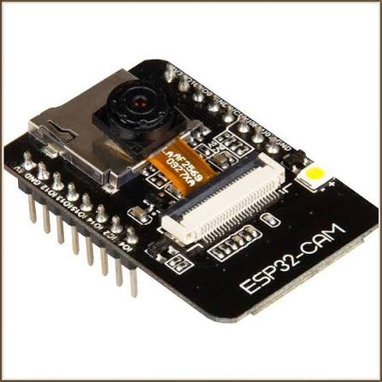
Figure 3.1.1
The ESP32-CAM is a low-cost microcontroller module with a built-in camera and Wi-Fi capability, used for IoT and image-processing applications. Based on the ESP32 chip, it supports wireless communication through Wi-Fi and Bluetooth, and can capture images, stream live video, and communicate with other devices over a network. In this project, the ESP32-CAM captures live video for face recognition and attendance monitoring. It can be programmed using the Arduino IDE and integrated with Python applications through IP-based streaming. Due to its compact size, low cost, and powerful features, the ESP32-CAM is widely used in smart surveillance, robotics, security systems, and face recognition applications.

3.1.2 R307 Fingerprint Sensor

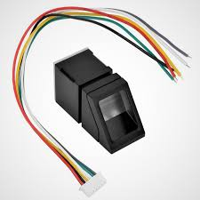
Figure 3.1.2
The R307 Fingerprint Sensor is a biometric authentication module used for fingerprint detection and verification. It can capture, store, and compare fingerprint patterns for secure identification, and supports serial communication with microcontrollers such as the ESP32. In this project, it provides an additional layer of security alongside face recognition, helping to prevent unauthorised access and improving the accuracy of the attendance system. Its fast response, reliability, and compact design make it widely used in security systems, smart locks, and attendance management applications.

3.1.3 ESP32 DevKit V1 (Main Controller)

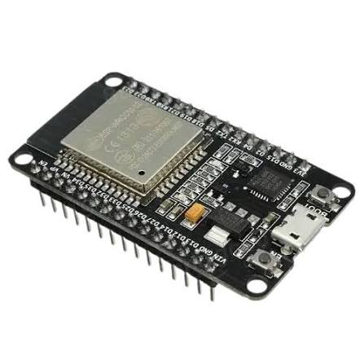
Figure 3.1.3
The ESP32 DevKit V1 serves as the main controller of the Smart Attendance System, coordinating all hardware components and managing overall operation. It communicates directly with the R307 Fingerprint Sensor and the OLED display over wired connections, while maintaining a wireless Wi-Fi link with the ESP32-CAM. During startup it initialises all connected peripherals, and during operation it processes fingerprint authentication results and controls the sequence of steps required for attendance verification.
The ESP32 receives the fingerprint ID from the R307 sensor through UART communication and verifies whether the scanned fingerprint belongs to a registered user. After successful fingerprint authentication, it sends a wireless command to the ESP32-CAM to capture the student's facial image, which is then processed by the Python application using OpenCV and the Face Recognition library. Throughout the process, the ESP32 continuously updates the OLED display with messages such as “Place Finger”, “Scanning Face”, “Attendance Marked”, and “Access Denied”.
Its dual-core processor, integrated Wi-Fi, multiple GPIO pins, and support for UART and I²C communication enable seamless interaction between the fingerprint sensor, OLED display, and ESP32-CAM, ensuring accurate attendance recording while minimising hardware complexity through wireless communication with the camera module.

3.1.4 SSD1306 OLED Display

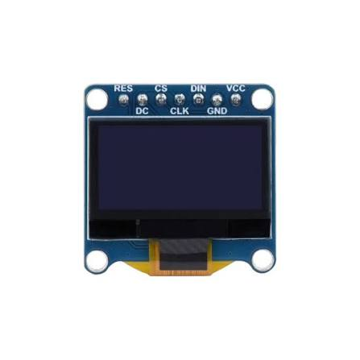
Figure 3.1.4
The SSD1306 OLED display is an electronic display module used to show text and status messages in embedded systems. It communicates with the ESP32 using the I²C protocol, requiring only SDA and SCL data lines in addition to power and ground. In this project, it displays the detected person's name, attendance status, and system messages in real time. Due to its low power consumption, reliability, and easy interfacing, it is widely used in Arduino, IoT, and embedded automation projects.

Chapter 4: Software Workflow and Code Architecture
The Smart Attendance System is built around the ESP32 DevKit V1, which acts as the main controller for the entire system. It manages communication with the fingerprint sensor and OLED display while coordinating with the ESP32-CAM through a wireless Wi-Fi connection. This architecture eliminates the need for direct serial communication between the ESP32 and ESP32-CAM, resulting in a cleaner and more flexible system design. During startup, the ESP32 initialises all connected peripherals and controls the overall operation of the attendance process, continuously monitoring the fingerprint sensor, updating the OLED display, and exchanging authentication data with the ESP32-CAM.
The R307 Fingerprint Sensor serves as the first layer of security. It is connected to the ESP32 through UART communication using the TX and RX pins, along with power and ground connections. When a student places a finger on the sensor, it captures the fingerprint image, extracts its unique biometric features, and compares them with the templates stored in internal memory. If a valid match is found, the sensor sends the corresponding fingerprint ID to the ESP32; if not, the authentication process stops immediately, preventing unauthorised attendance marking.
The ESP32-CAM is responsible for capturing the student's facial image after successful fingerprint verification. It communicates wirelessly with the ESP32 over Wi-Fi rather than a wired connection, making the system more compact and reducing cable complexity. Once the ESP32 receives confirmation from the fingerprint sensor, it sends a wireless request to the ESP32-CAM to capture an image, which is then transmitted to the Python application running on a computer, where OpenCV and the Face Recognition library process and identify the student's face.
The OLED display provides real-time visual feedback throughout the authentication process via the I²C protocol, showing messages such as “Place Finger”, “Scanning Face”, “Attendance Marked”, and “Access Denied”, so users can follow the current stage of authentication without needing to look at a computer screen.
The circuit is powered using a stable 5V supply, with the OLED display operating at 3.3V logic through the ESP32. All hardware components share a common ground to ensure proper electrical reference and stable communication. Since the ESP32-CAM communicates wirelessly, only its power connections are required, reducing the number of physical interconnecting wires, improving portability, and simplifying assembly and future maintenance.
Overall, the circuit integrates embedded hardware, wireless communication, and computer vision into a single smart attendance platform: the ESP32 functions as the central controller, the fingerprint sensor provides the first level of authentication, the ESP32-CAM performs facial image acquisition, and the OLED display offers instant user feedback. After successful fingerprint and face verification, the attendance information is processed by the Python application and stored in a CSV database.
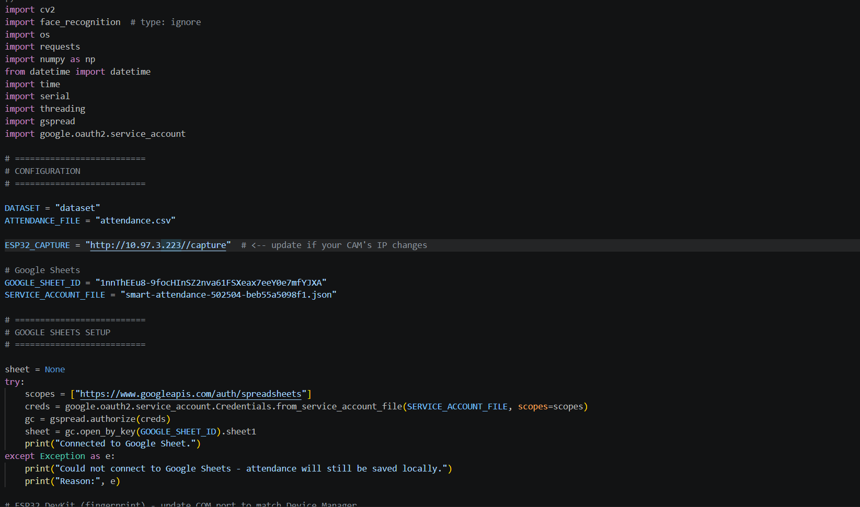

Figure 4

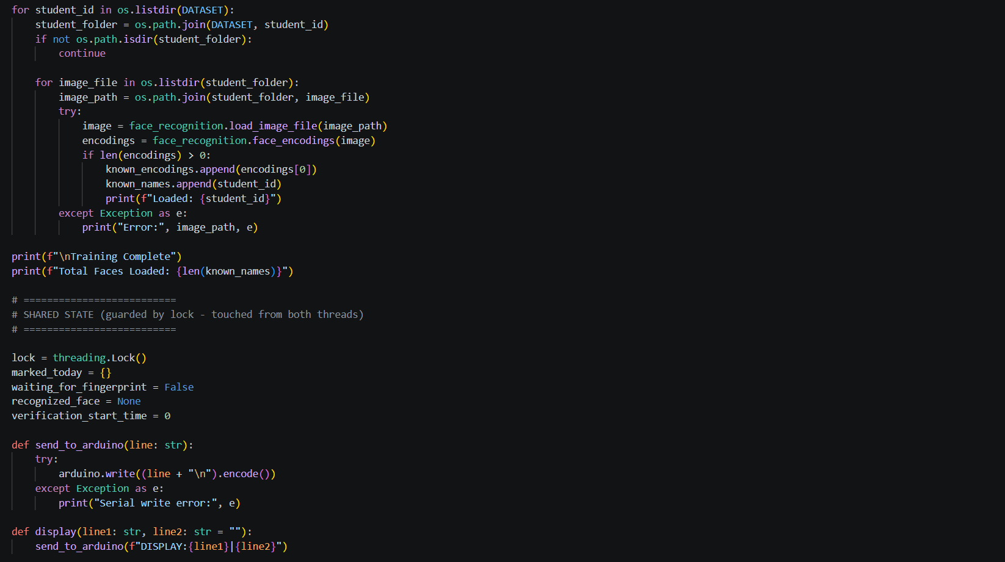

Figure 4

Chapter 5: Methodology

5.1 BLOCK DIAGRAM

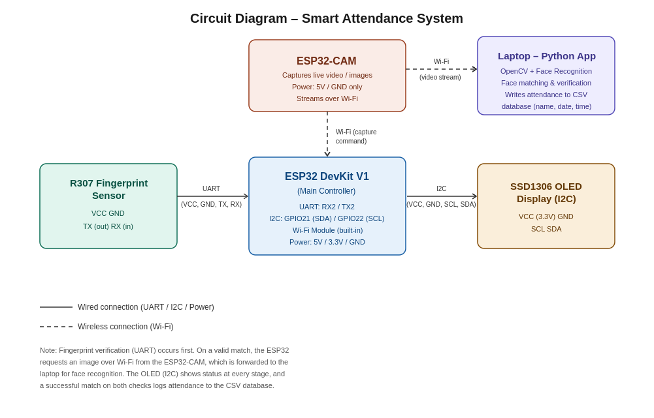
Figure 5.1

5.2 Flow of the Project
The Smart Attendance System is developed to provide a secure, automated, and intelligent attendance monitoring solution using face recognition and fingerprint authentication. The system consists of the ESP32-CAM, ESP32 DevKit V1, R307 Fingerprint Sensor, SSD1306 OLED display, and a Python-based face recognition program. Together these components create a reliable, real-time attendance management system that minimises manual work, improves security, and prevents proxy attendance.
The working process begins when the ESP32-CAM module is powered on and connects to the Wi-Fi network, generating an IP address through which its live video stream can be accessed. The captured video frames are transmitted wirelessly to the Python application running on a laptop, which receives the live feed using the ESP32-CAM's IP address and processes the frames for face detection and recognition.
The Python application is built using OpenCV, Face Recognition, NumPy, and Requests. OpenCV handles image processing and video frame handling, while the Face Recognition library compares the detected face with a stored dataset. At startup, the program loads all dataset images of authorised users and converts them into encoded facial features, which are kept in memory for comparison during live recognition.
When a user stands in front of the ESP32-CAM, the system captures their face from the live video stream, detects the facial region, and extracts facial features for comparison against the stored encodings. If the detected face matches an authorised user, the system identifies the person and displays their name; if not, the user is marked as “Unknown” and the process moves to the failure condition, at which point fingerprint verification is required to complete authentication.
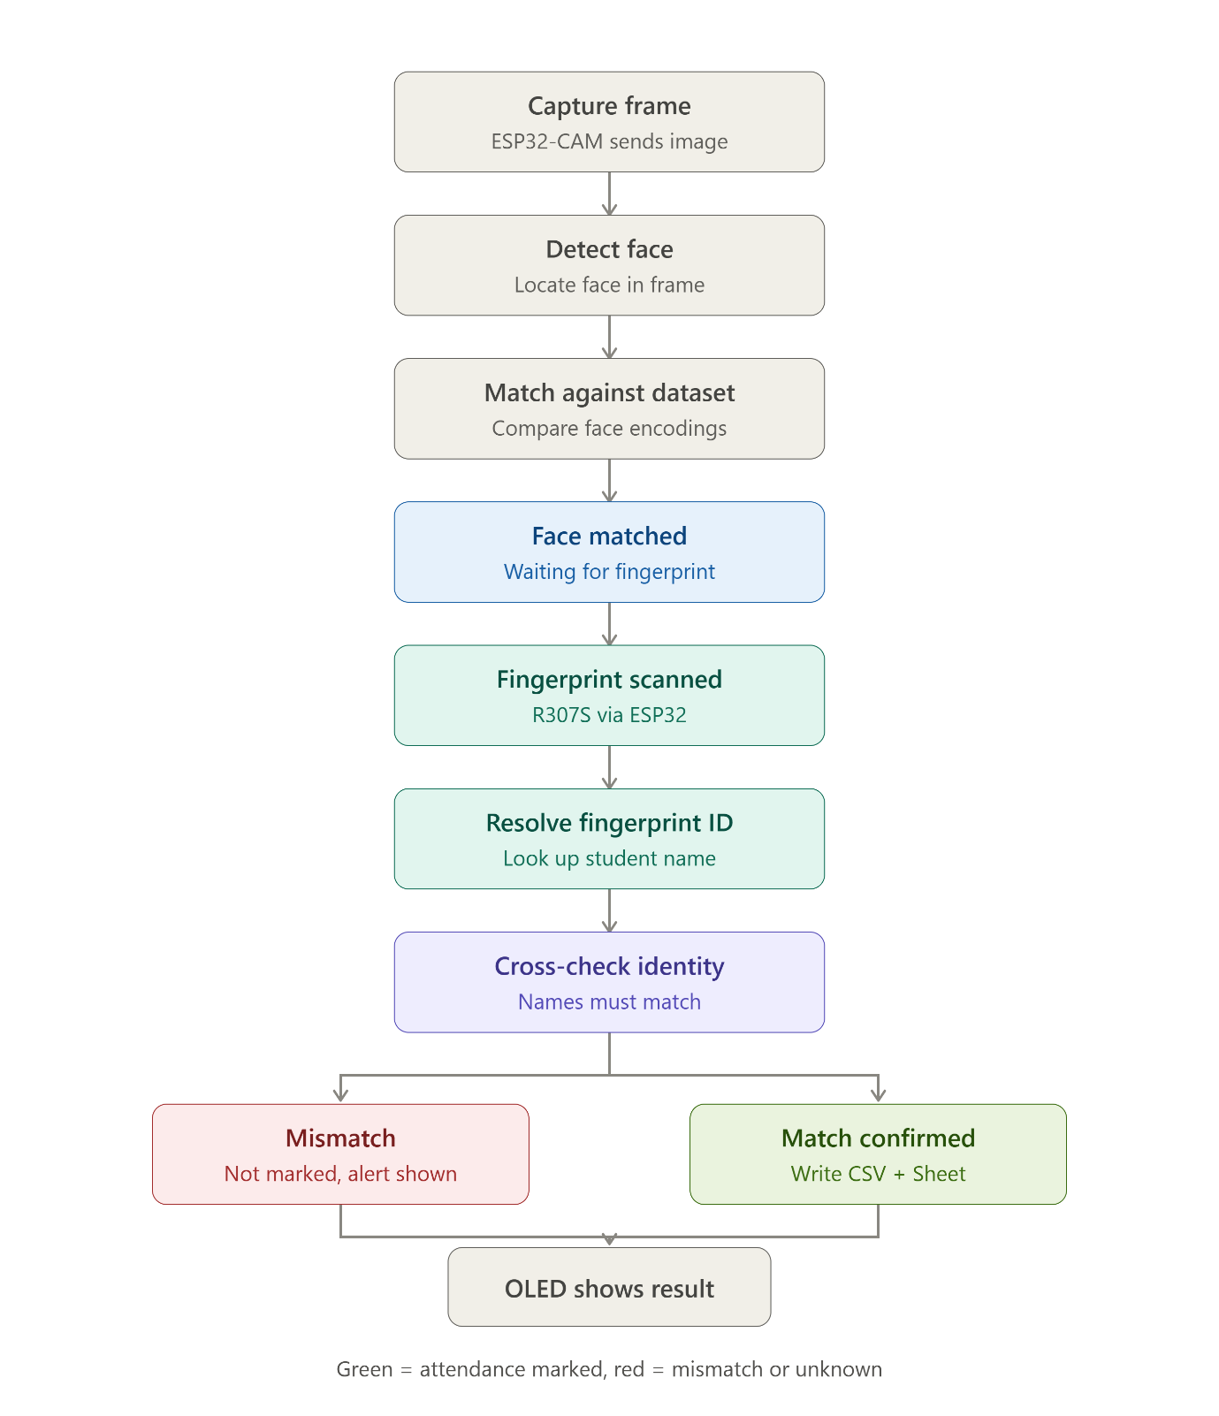
Figure 5.

5.3 Circuit Diagram and Description

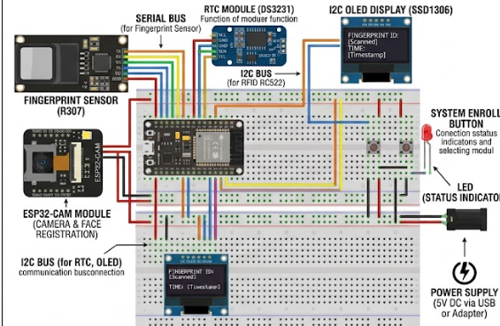
Figure 5.3
The circuit diagram represents the hardware architecture of the Smart Attendance System. The system consists of four main components: the ESP32 DevKit V1, the ESP32-CAM, the R307 Fingerprint Sensor, and the SSD1306 OLED display. The ESP32 DevKit functions as the central controller, managing communication with the fingerprint sensor and OLED display while communicating wirelessly with the ESP32-CAM over Wi-Fi. This wireless link reduces the number of physical connections, making the system compact, flexible, and easier to maintain.
The R307 Fingerprint Sensor is connected directly to the ESP32 DevKit using UART communication: its VCC pin connects to the 5V supply, GND to common ground, its TX pin to the ESP32's RX2 pin, and its RX pin to the ESP32's TX2 pin. This serial link allows the ESP32 to receive fingerprint data, verify registered users, and identify the corresponding fingerprint ID as the first level of security.
The ESP32-CAM acts as the image acquisition module. Rather than a wired serial connection, this project uses the built-in Wi-Fi capability of both ESP32 boards to communicate wirelessly. The ESP32-CAM is powered using only 5V and GND connections, while image-capture requests and status information are exchanged wirelessly. Once the ESP32 receives a valid fingerprint match, it sends a wireless command to the ESP32-CAM to capture the user's facial image, which is then forwarded to the Python application for facial identification using OpenCV and the Face Recognition library.
The SSD1306 OLED display is connected to the ESP32 using the I²C protocol, requiring only VCC, GND, SCL, and SDA connections. It is powered from the ESP32's 3.3V output, with SCL connected to GPIO22 and SDA to GPIO21. Throughout operation, the OLED provides real-time feedback with messages such as “Place Finger”, “Scanning Face”, “Attendance Marked”, and “Access Denied”.
Proper power distribution is essential for stable operation: the ESP32 DevKit and ESP32-CAM are powered from a 5V supply, while the OLED display operates at the 3.3V logic level provided by the ESP32. All hardware modules share a common ground to ensure reliable communication and prevent voltage-reference issues. The fingerprint sensor communicates over UART, while the OLED display communicates over I²C; because the ESP32-CAM exchanges data wirelessly, no UART wiring is required between the two ESP32 boards, which significantly reduces cable clutter and simplifies the circuit layout.
Overall, the circuit combines embedded hardware, wireless communication, and computer vision into a secure and efficient attendance system: the ESP32 coordinates all hardware operations, the fingerprint sensor performs the first level of authentication, the ESP32-CAM captures facial images for verification, and the OLED display provides instant visual feedback to the user.
Chapter 6:
OUTCOMES

- Dual biometric authentication implemented successfully — fingerprint verification (R307 sensor) and face recognition (ESP32-CAM + Python/OpenCV) work together, marking attendance only when both checks match the same registered user.

- Proxy attendance and unauthorised access eliminated — since a single layer of verification is no longer enough, false or manipulated attendance entries are effectively prevented.

- Reliable wireless communication achieved — the ESP32 DevKit V1 and ESP32-CAM exchange data over Wi-Fi instead of wired serial links, simplifying the circuit and reducing hardware complexity.

- Fully automated attendance logging — once verification succeeds, the system records the student's name, date, and time directly into a CSV database without manual intervention.

- Real-time user feedback via OLED display — status messages ("Place Finger", "Scanning Face", "Attendance Marked", "Access Denied") guide the user through each stage, making the system easy to use.

- Low-cost, scalable working prototype — the system was built from affordable, off-the-shelf components (ESP32-CAM, ESP32 DevKit V1, R307 sensor, OLED) while remaining suitable for future upgrades like cloud storage and mobile app integration.

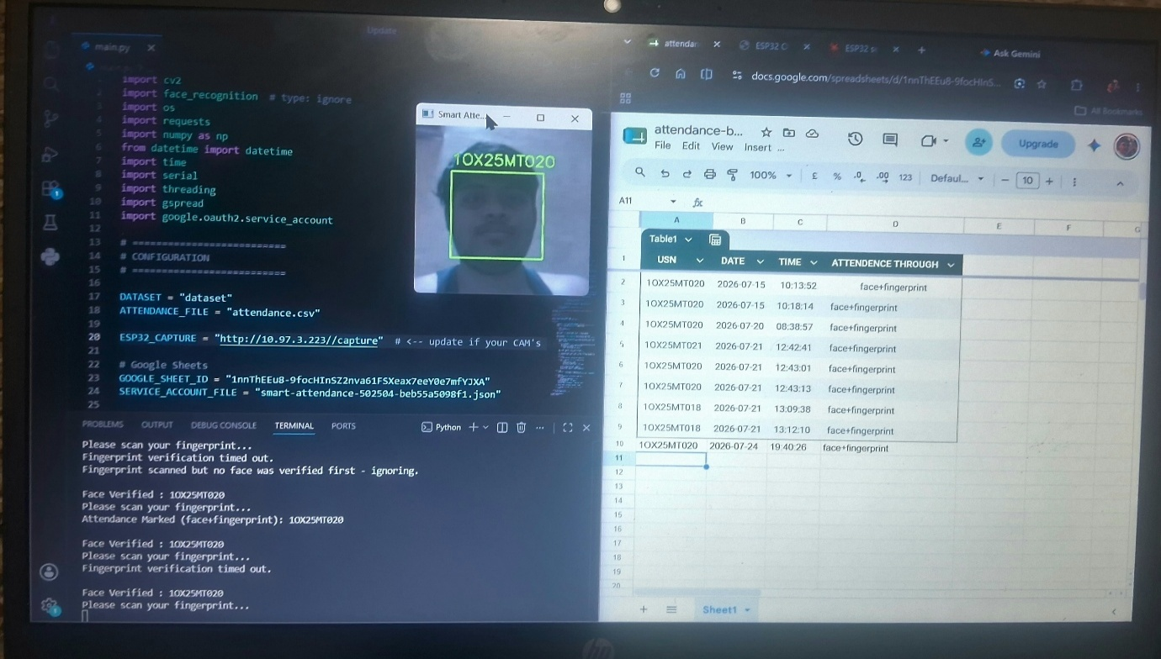

Figure 6
Chapter 7: Conclusion, Advantages, and Applications

7.1 Conclusion

The project successfully develops a secure, automated Smart Attendance System combining ESP32-CAM based face recognition with R307 fingerprint authentication for accurate, reliable user verification.

Dual-layer authentication (face + fingerprint) prevents proxy attendance, unauthorised access, and the manual errors common in traditional attendance systems.

The ESP32-CAM captures live video and transmits it wirelessly to a Python application, where OpenCV and the Face Recognition library match the user against stored dataset images.

Once both fingerprint and face verification succeed, attendance is recorded automatically in a CSV database with the date and time, while the OLED display gives instant status feedback.

The system demonstrates practical integration of artificial intelligence, computer vision, embedded systems, IoT, and biometric security into a single working application.

It is low-cost, portable, and scalable, making it suitable for schools, colleges, offices, industries, and other secure environments — reducing paperwork, saving time, and improving accuracy.

The design leaves clear room for future enhancement through cloud storage, mobile applications, and database integration for large-scale deployment.

7.2 Advantages
- Marks attendance automatically without manual entry or paperwork, saving time and effort.
- Uses both face recognition and fingerprint authentication for accurate, reliable dual verification.
- Verifies both face and fingerprint before marking attendance, minimising proxy attendance and false entries.
- Records attendance instantly with date and time, stored automatically in a CSV database.
- Provides real-time feedback via the OLED display, keeping the system simple and quick to use.
- Built from affordable components (ESP32-CAM, ESP32 DevKit V1, R307 sensor) and easy to upgrade with cloud storage and mobile apps.

7.3 Applications
- Schools and Colleges – automatic student attendance management with digital record-keeping.
- Offices and Companies – employee attendance tracking with improved security and fewer manual errors.
- Industries and Factories – worker attendance and secure entry/access control.
- Laboratories and Research Centres – restricted access and attendance monitoring for authorised personnel only.
- Smart Security Systems – biometric-based identification integrated into surveillance applications.
- Government and Secure Organisations – identity verification and secure, accurate employee records.

Chapter 8: Future Scope
The future scope of the Smart Attendance System is promising given the growing demand for automation, security, and smart monitoring in educational institutions, offices, industries, and secure environments. Integrating IoT, artificial intelligence, cloud computing, and web-based monitoring can make the project more efficient, scalable, and intelligent, enabling real-time monitoring, remote accessibility, centralised data management, and enhanced biometric security.
- IoT-Based Cloud Integration: Upload attendance records directly to cloud servers (like Firebase or Google Cloud) via Wi-Fi for seamless remote monitoring.
- Mobile Application Integration: Provide dedicated Android and iOS apps so administrators, employees, or parents can access reports and receive instant notifications on the go.
- AI-Based Face Recognition: Utilize deep learning to ensure high recognition accuracy across varying angles and low-light conditions, alongside mask detection and suspicious-activity monitoring.
- Database and Server Storage: Deploy MySQL or scalable cloud databases to handle large-scale attendance data, automate report generation, and power analytics.
- RFID and Smart Card Integration: Add RFID or NFC smart cards as a secondary authentication layer to speed up the attendance-marking process in high-volume industrial settings.
- Web-Based Monitoring Dashboard: Create a centralized online portal featuring graphical data visualization for real-time, at-a-glance attendance tracking.
- Research and Development: Continuously optimize hardware for faster performance and lower power consumption while implementing stronger encryption and security algorithms.
In summary, the future of the Smart Attendance System lies in integrating IoT, artificial intelligence, cloud computing, and smart automation technologies to become a highly secure, intelligent, scalable, real-time monitoring solution.

Chapter 9: Reference

- Kortli, Y., Jridi, M., Al Falou, A., & Atri, M. published the paper "Face Recognition Systems: A Survey" in the journal Sensors in 2020.
- Parkhi, O. M., Vedaldi, A., & Zisserman, A. published the paper "Deep Face Recognition" in the British Machine Vision Conference (BMVC) in 2015.
- Jain, A. K., Ross, A., & Prabhakar, S. published the paper "An Introduction to Biometric Recognition" in the IEEE Transactions on Circuits and Systems for Video Technology in 2004.

- Zhao, W., Chellappa, R., Phillips, P. J., & Rosenfeld, A. published the paper "Face Recognition: A Literature Survey" in ACM Computing Surveys in 2003.

- Daugman, J. published the paper "How Iris Recognition Works" in the IEEE Transactions on Circuits and Systems for Video Technology in 2002.

- Viola, P., & Jones, M. published the paper "Rapid Object Detection Using a Boosted Cascade of Simple Features" in the IEEE Computer Society Conference on Computer Vision and Pattern Recognition (CVPR) in 2001.

- Turk, M., & Pentland, A. published the paper "Face Recognition Using Eigenfaces" in the IEEE Computer Society Conference on Computer Vision and Pattern Recognition (CVPR) in 1991.

